create database joins;

use joins;

drop database joins;

create table employee(

emp_id int primary key auto_increment,

emp_name varchar(50),

dept_id int,

salary int);

insert into employee(emp_name,dept_id,salary)

values("Alice",101,6000),

("Bob",102,7000),

("Charlie",103,8000),

("David",101,7500),

("Eve",102,8500);

create table departments(

dept_id int,

dept_name varchar(50));

insert into departments(dept_id,dept_name)

values(101,"HR"),

(102,"Sales"),

(103,"IT"),

(104,"Marketing");

create table projects(

project_id int,

project_name varchar(30),

dept_id int);

insert into projects(project_id,project_name,dept_id)

values(1,"Project A", 101),

(2,"Project B",102),

(3,"Project C",103),

(4,"Project D",104);

#find all employee who work in sales department

select employee.emp_name, departments.dept_name from employee

right join departments on employee.dept_id=departments.dept_id where departments.dept_name="Sales";

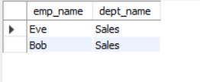

# Find departments name who have employees

select employee.emp_name as "employee name",departments.dept_name as "department name" from employee Inner Join departments on departments.dept_id = employee.dept_id;

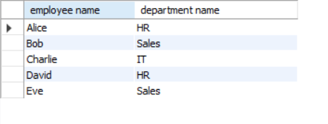

# #find the employees who have salary hiher than 7500 and work in project an an it department

select employee.emp_name,departments.dept_name from employee inner join departments on employee.dept_id = departments.dept_id where dept_name="IT"and salary>7500;



# #find number of employees in each department

select count(emp_id),departments.dept_name as"dept_name" from employee Inner Join departments on employee.dept_id = departments.dept_id group by dept_name;

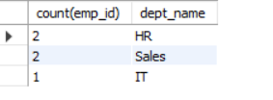

# Get total salary of each department

select sum(salary),departments.dept_name as"dept_name" from employee Inner Join departments on employee.dept_id = departments.dept_id group by dept_name;

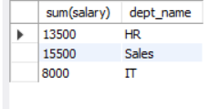

# Find all departments that have no employees

SELECT departments.dept_id, departments.dept_name FROM departments LEFT JOIN employee ON departments.dept_id = employee.dept_id WHERE Employee.dept_id IS NULL;



# list the employee names and their respective project names

select employee.emp_name,projects.project_name from employee inner join projects on employee.dept_id=projects.dept_id;

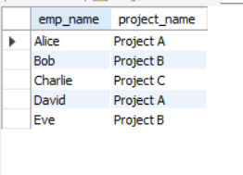

# Find the employee and project name for employees in 'HR' department

select employee.emp_name,projects.project_name from employee inner join departments on departments.dept_id = employee.dept_id

inner join projects on employee.dept_id=projects.dept_id where departments.dept_name="HR";



# Retrive departments with more than 1 project assigned

select departments.dept_name,count(projects.dept_id)from projects right join departments on projects.dept_id=departments.dept_id

group by departments.dept_name having count(projects.dept_id)>1;



# Retrive departments with 1 project assigned

select projects.project_name from departments left join projects on departments.dept_id=projects.dept_id

group by projects.project_name having count(departments.dept_id)=1;

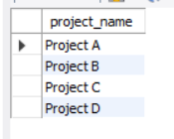

# Find employees who work in departments that are not assigned any projects

select departments.dept_name,employee.emp_id from employee left join departments on employee.dept_id=departments.dept_id

left join projects on departments.dept_id=projects.dept_id

group by departments.dept_name,employee.emp_id having count(projects.dept_id)=1;

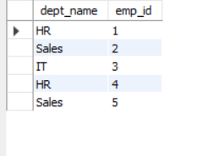

# List the departments along with the number of employees and projects

select distinct(departments.dept_name),count(employee.emp_id),count(projects.project_id) from departments left join employee on departments.dept_id=employee.dept_id

left join projects on departments.dept_id=projects.dept_id

group by departments.dept_name,employee.emp_id,projects.project_id;

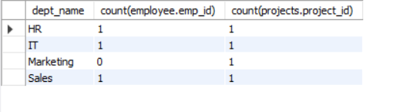

# Get the department name and total salary spent on employees for departments with at least 2employees

select d.dept_name,count(e.emp_id),sum(salary) from departments d inner join employee e on d.dept_id=e.dept_id group by dept_name having count(emp_id)=2;

